
SPECIALIST MATHS
TRIAL EXAMINATION 2
2002
SOLUTIONS

_____________________________________________________________________

Question 1

a. i. From the diagram, 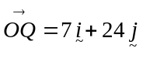.
(1 mark)
ii. Similarly, 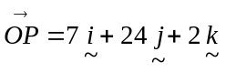.
(1 mark)
b. i. The vector component of 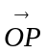 perpendicular to 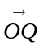 is given by
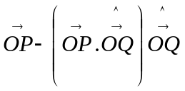 (1 mark)
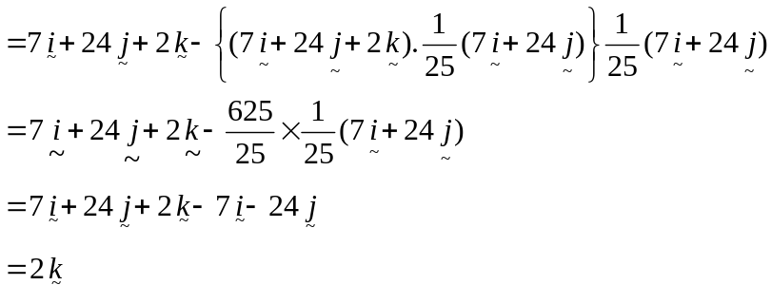
as required (1 mark)

- Method 1
From the diagram, 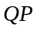 is the component of perpendicular to .
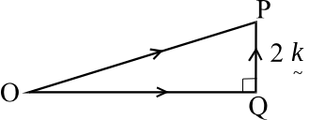
(1 mark)
So, 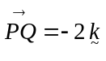
(1 mark)

Method 2

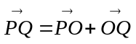 (1 mark)
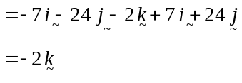
(1 mark)
c. Now, 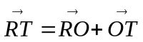
Now, from the diagram, 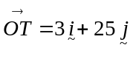. (1 mark)
We need to find 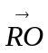.
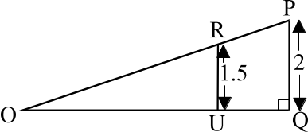
Now, 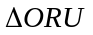 is similar to 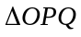.
So, 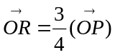 (1 mark)
Now, 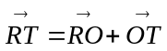
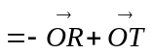
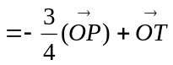 (1 mark)
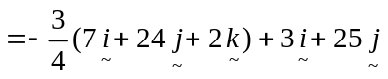
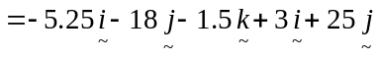
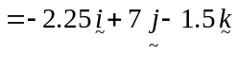 as required (1 mark)

d. We are looking for the angle of deflection 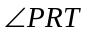. We want to find the angle between the vectors 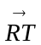 and 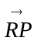. Since runs parallel to ,we seek to find the angle between the vectors and . (1mark)
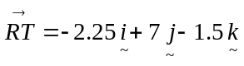
and 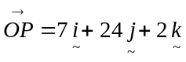
So, 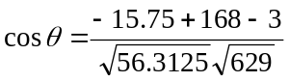 (1 mark)
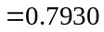
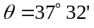
So the angle of deflection is 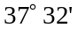 (to the nearest minute) (1mark)

Total 13 marks
Question 2

a. 10.00am corresponds to 3 hours after work started so 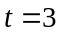.
Now 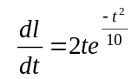
When 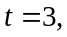 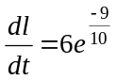
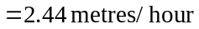
So, at 10.00am, the rate at which the path is being laid is 2.44 metres/hour (correct to 2 decimal places).
(1 mark)
b. i. We are looking for 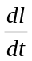 to be a maximum. This will occur when 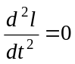.
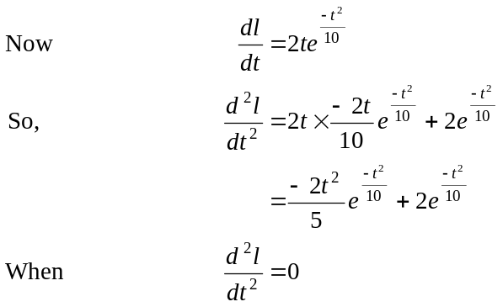
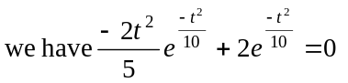 (1mark)
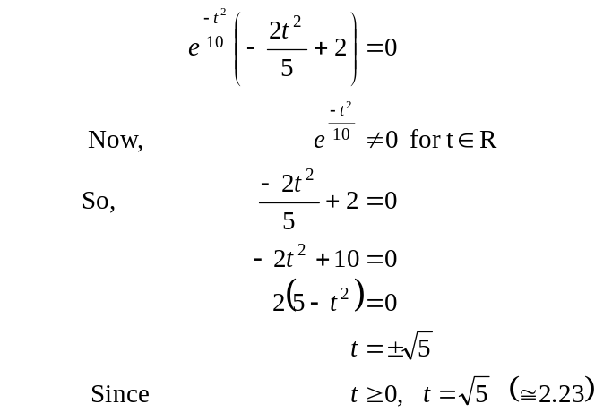
Check for a maximum.
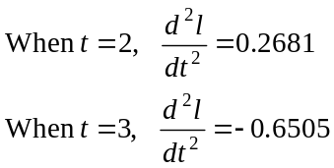
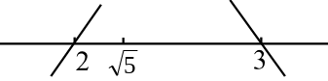

So we have a maximum at 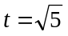. (1 mark)
So the fastest rate occurs at hours.
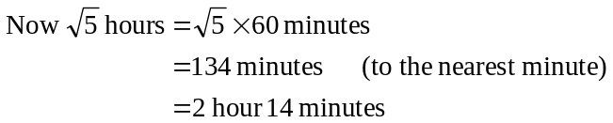
So the time at which the path is being laid fastest is 9.14am.
(1 mark)
ii. From part i., the fastest rate at which the landscape gardener lays the path occurs at .
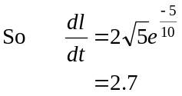
So, the fastest rate at which the landscape gardener lays the path is 2.7 metres/hour (correct to one decimal place). (1 mark)
c. We need to solve, simultaneously, the equations
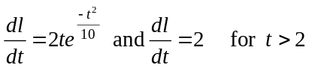.
Using a graphics calculator we find that the two respective graphs intersect at 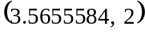.
So, after 3 hours and 34 minutes (to the nearest minute) or at 10.34am, the rate at which the path is being laid drops below 2 metres per hour.
(1 mark)

d. 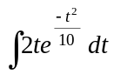
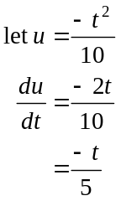
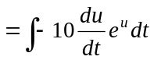 (1 mark)
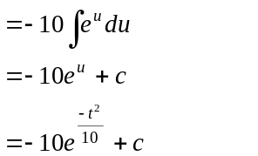
(1 mark)

e. We need to evaluate
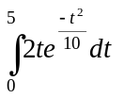 (1 mark)
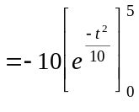
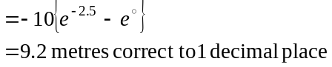
(1 mark)
Total 10 marks
Question 3
a.
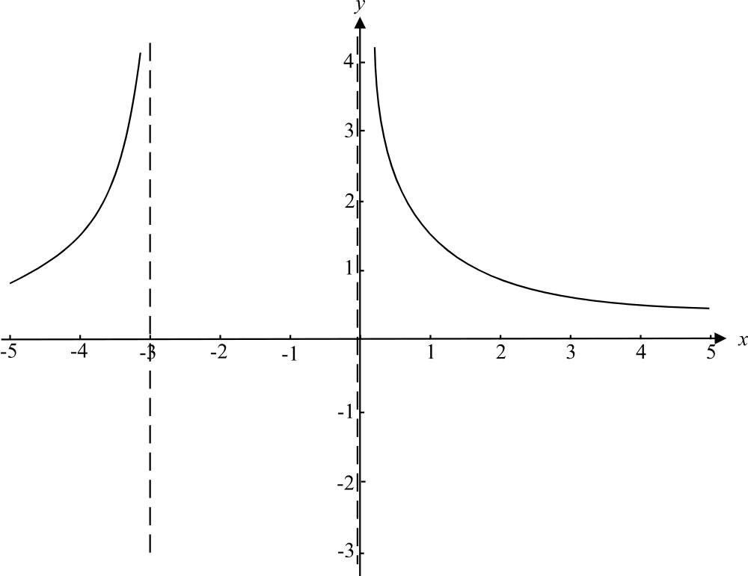

(1 mark) asymptotes
(1 mark) shape
b. 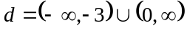 (1 mark)
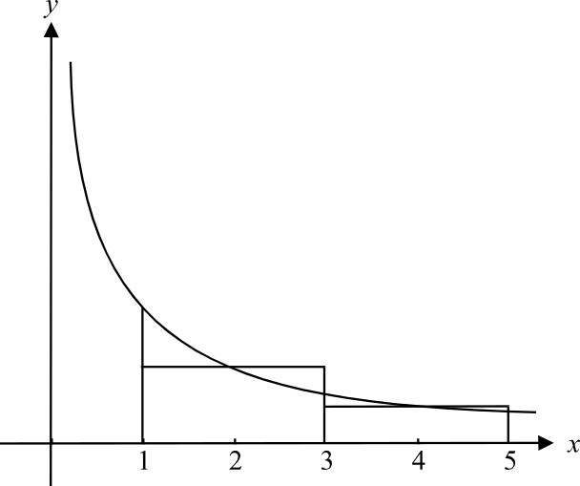
c.

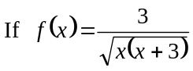
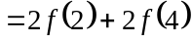 (1 mark)
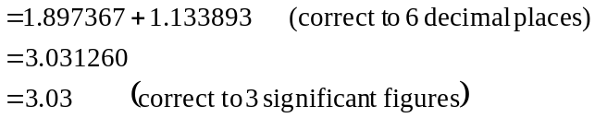
(1mark)
- The area required is shown in the diagram below broken into 3 sections.
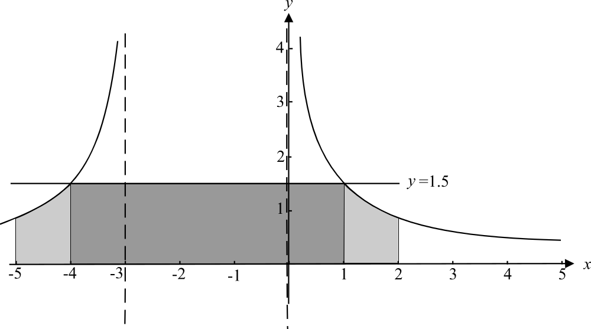

To find the middle, darker area, we need to find the points of intersection between
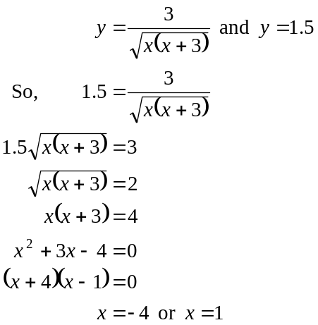
So the middle section has an area of (1 mark)
Total area required 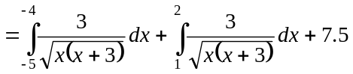 (1 mark)
Using a calculator, we obtain
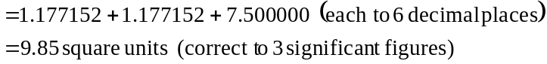
(1 mark)

e.
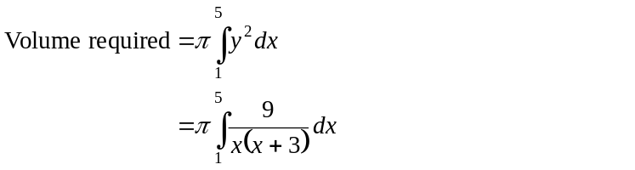
(1 mark)
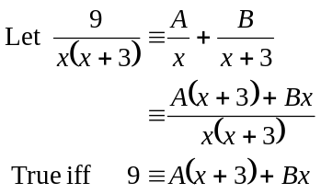
Put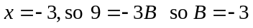
Put 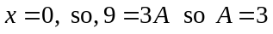
So, 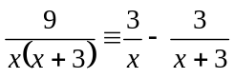
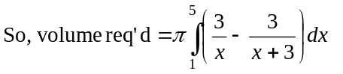 (1 mark)
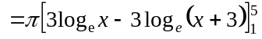 (1 mark)
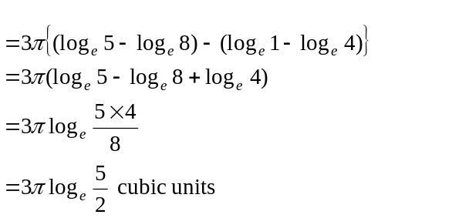
(1 mark)

Total 12 marks
Question 4
- i.
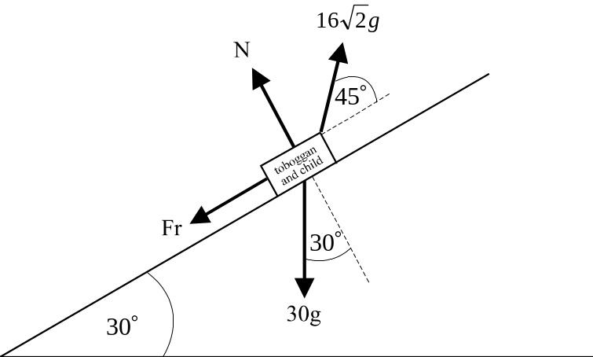

(2 marks)
ii. Resolve forces, given that represents a unit vector parallel with the
slope and represents a unit vector perpendicular to the slope.
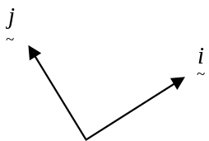

Now, 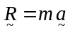 becomes
Note that since we have constant speed, 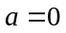.
(1 mark) for the left hand side of the equation
(1 mark) for the right hand side of the equation
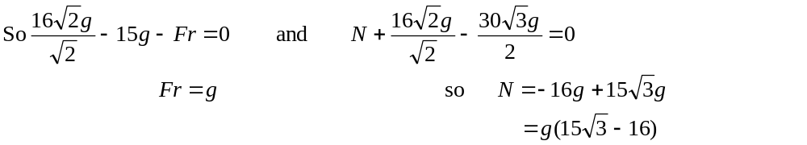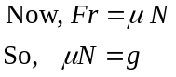 (1 mark)
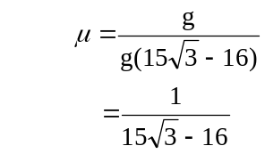
as required (1 mark)
b i. Now, 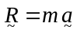
This time,
(1 mark)
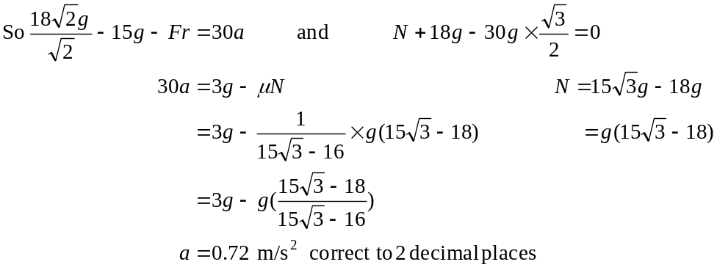 (1 mark)
ii. Since acceleration is constant, we have,
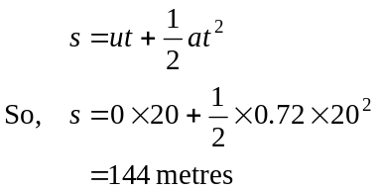
(1 mark)
iii. Again, since acceleration is constant we have
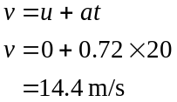
(1 mark)
c. i.
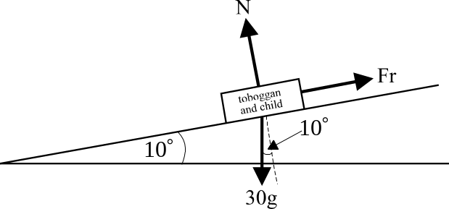

(2 marks)

ii. Resolving the forces, we have
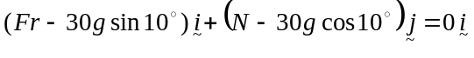
So, (1 mark)
Now at the point of limiting equilibrium, when the toboggan is about to slide, 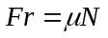
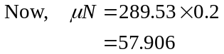
and from above, 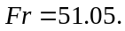
So 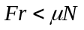
So, the toboggan is not on the point of sliding down the slope.
(1 mark)
Total 14 marks

Question 5
a. i.
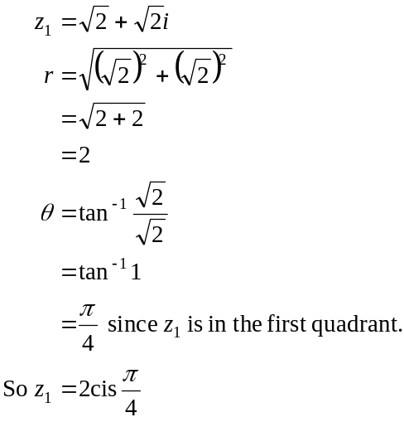
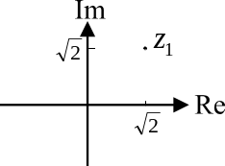
(1 mark)
ii. Method 1
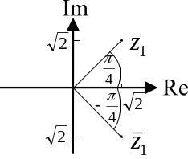
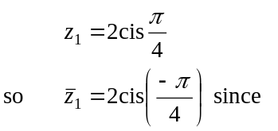
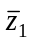, is located by reflecting 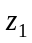 in the Real axis.
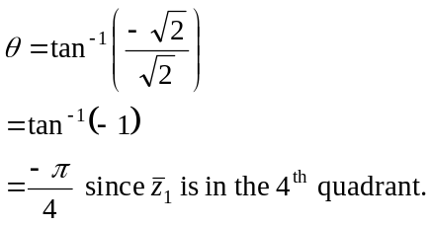

Method 2
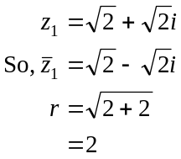
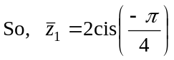 (1 mark)
iii. 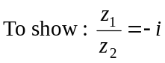
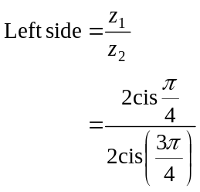
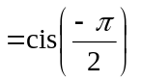 (1mark)
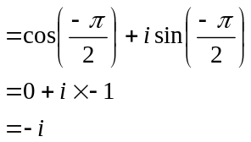
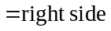 Have shown.
(1 mark)
b. Firstly, express 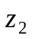 in the form 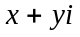.
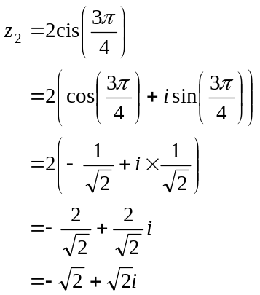
(1 mark)
Now the equation is given by
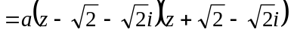 (1 mark)
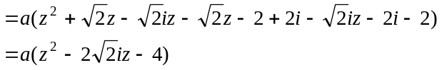
So 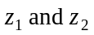 could be the roots of any quadratic equation of the form 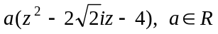.
(1 mark)
c. i. We know that 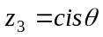
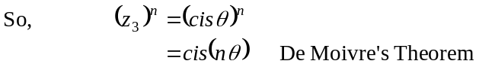
(1 mark)

ii. To show: 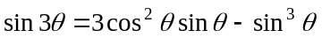
From part c. i., we have
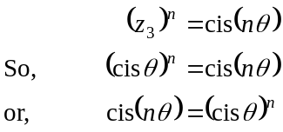
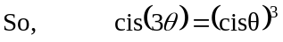 (1 mark)
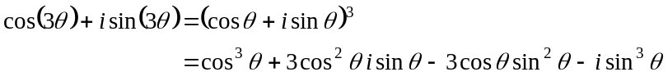
(1 mark)
Equating imaginary parts, we have,
as required. (1 mark)
Have shown.

Total 11 marks

